**How to Edit the Services Page Content**

**Step 1: Log in to WordPress Admin Panel**

* Go to your admin dashboard.
* Enter your admin credentials to log in.

**Step 2: Navigate to the Pages Section**

* In the left sidebar menu, click on **Pages > All Pages**.

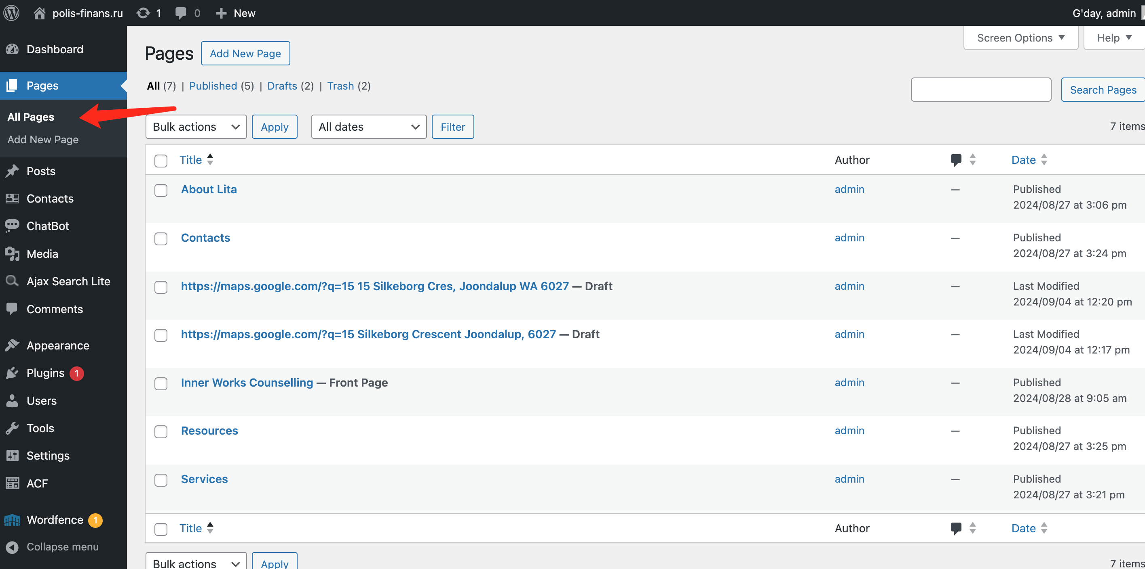

**Step 3: Locate and Edit the ‘Services’ Page**

* On the **Pages** screen, find the **Services** page in the list of pages.
* Hover over the **Services** page title and click **Edit**.

**Step 4: Edit the Content of the Services Page**

* **Edit the Title:**
  + At the top of the page editor, you’ll see the title field.
  + Click the title field to edit the current title (e.g., change "Services" to "Our Services").
* **Edit Existing Service Descriptions:**
  + Scroll down to the main content editor.
  + Click on the paragraph block containing the service description you want to modify.
  + Use the text editing toolbar above the paragraph to format your content (bold, italic, links, etc.).
  + Type or paste new content directly into the block to update the service descriptions.

**Step 5: Add New Service Sections (Optional)**

* To add a new service section, click on the "+" icon at the top left of the editor.
* Select the appropriate block type, such as a paragraph, heading, or image block, and add the new service content.

**Step 6: Adding/Editing Images for Services**

* If you have images associated with services:
  + Click on the existing image to edit it, then click the **pencil icon** to modify details or the **X icon** to remove it.
  + To add a new image, select the image block, upload a new image, or choose one from the media library.
  + You can align and size the image using the toolbar that appears when you select it.

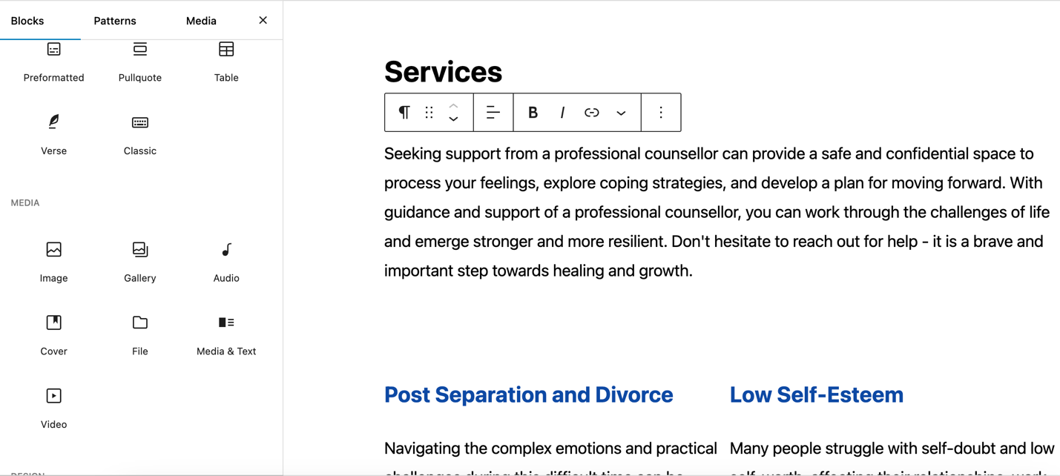

**Step 7: Preview and Save Changes**

* **Preview:** Click the laptop icon in the top right corner to preview how the page looks across different devices:
  + **Desktop:** See how the page looks on desktop screens.
  + **Tablet:** Check how the page appears on tablet devices.
  + **Mobile:** View the mobile version of the page.
  + **Preview in New Tab:** Open a full preview of the page in a new browser tab.
* **Save:** After making the necessary changes, click the **Save** button to publish your updates.

**Step 8: Rollback Changes (Optional)**

* If you are not happy with the changes you made, or want to undo or redo changes:
  + Use the undo/redo icons in the toolbar at the top of the editor.
  + If you want to discard changes and quit without saving, click the **WordPress icon** at the top left and confirm that you do not want to save changes.